**Community Asset Map**

Physical Space

Associations

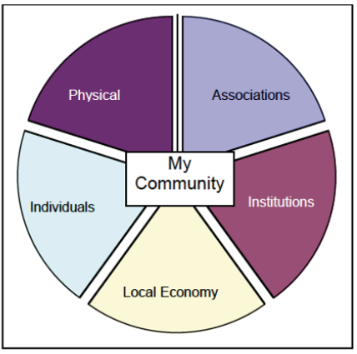

Individuals

Local Economy

Institutions